Hello NFJS API Gateway

## Create a New API

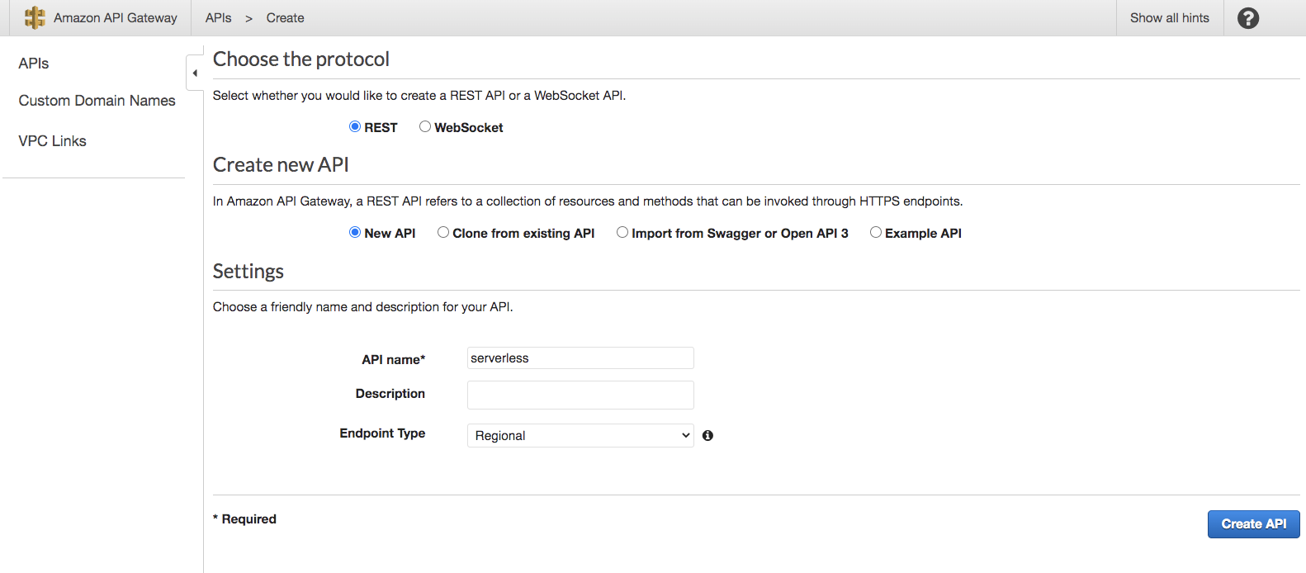

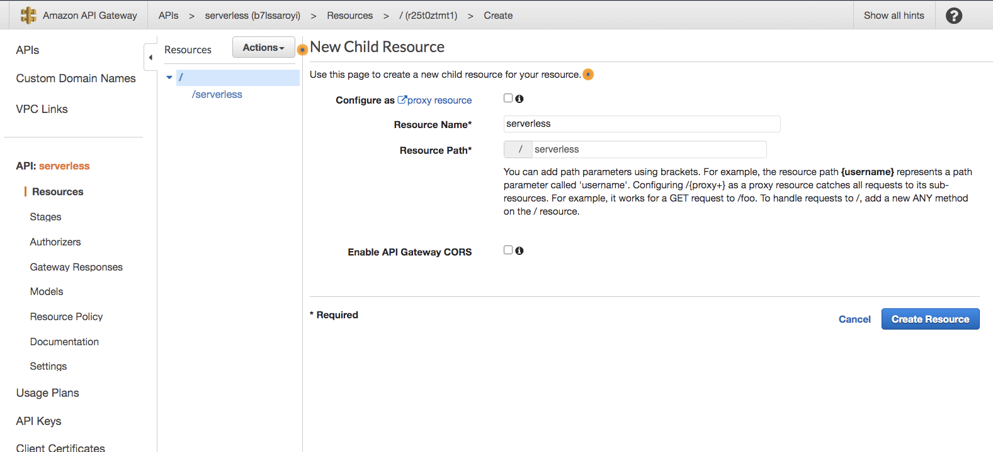

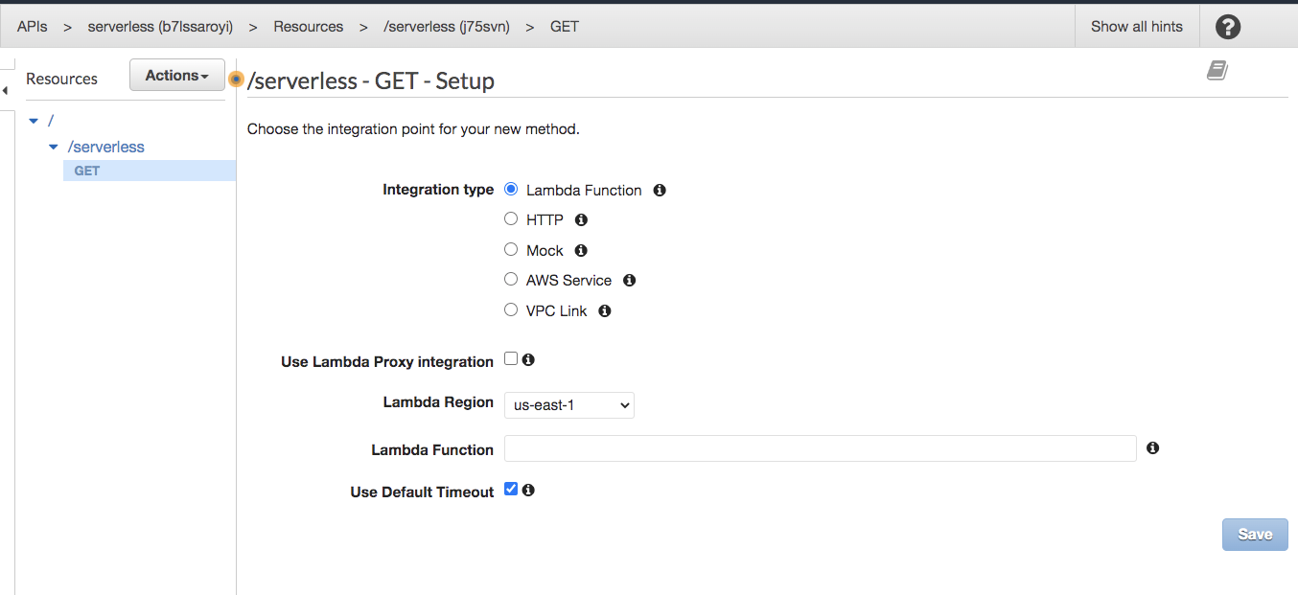

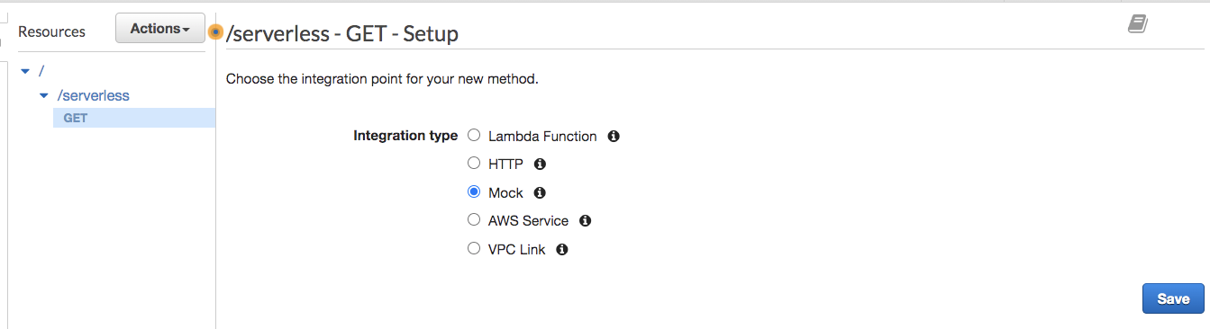

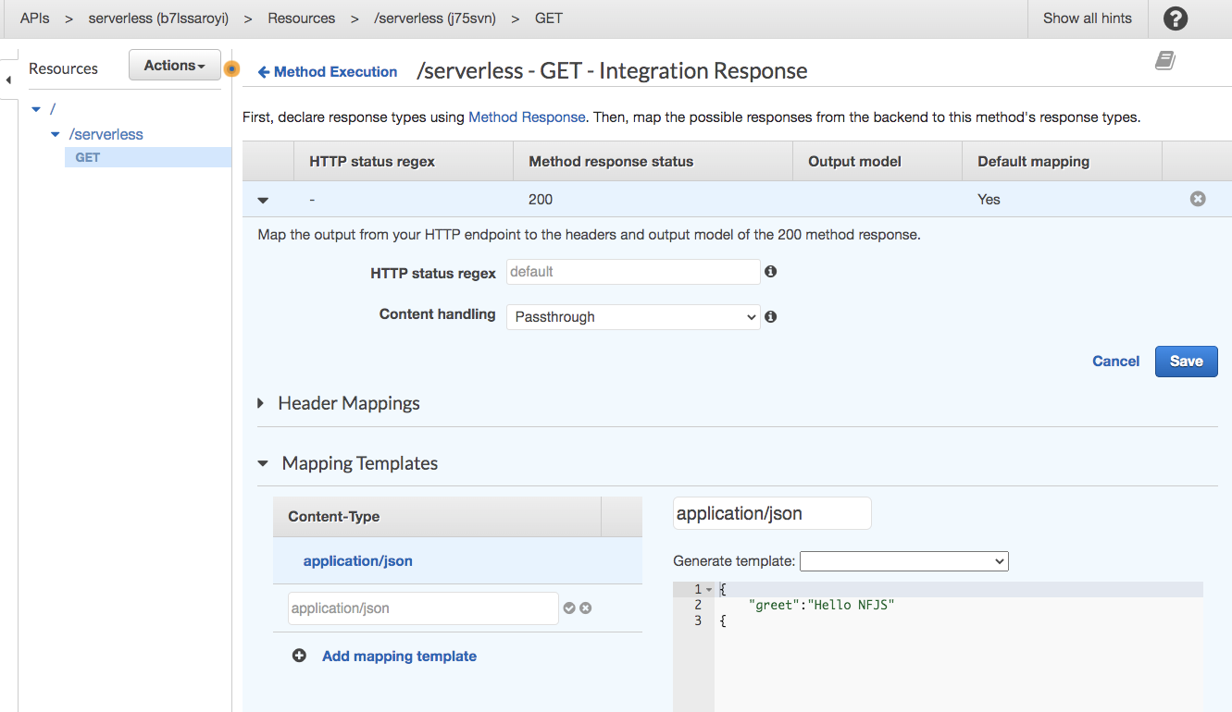

{

"greet":"Hello NFJS"

{

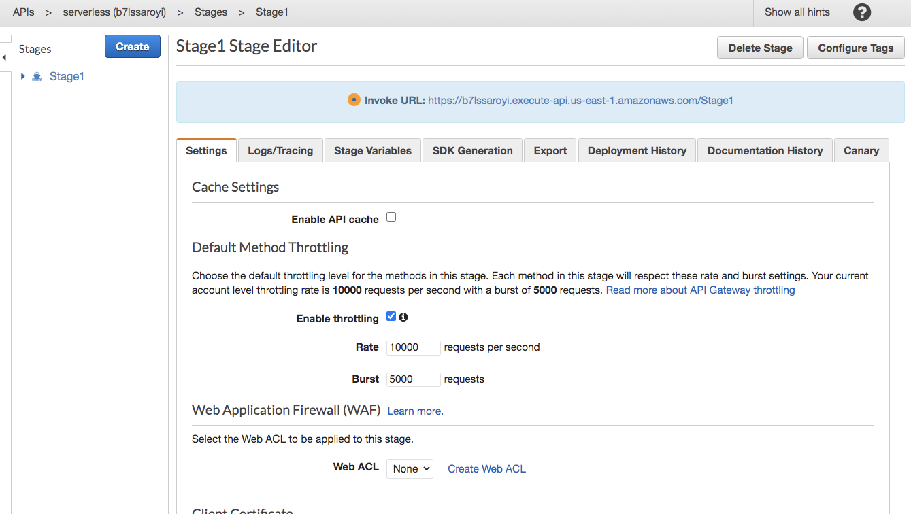

Test:

<https://b7lssaroyi.execute-api.us-east-1.amazonaws.com/Stage1/serverless>